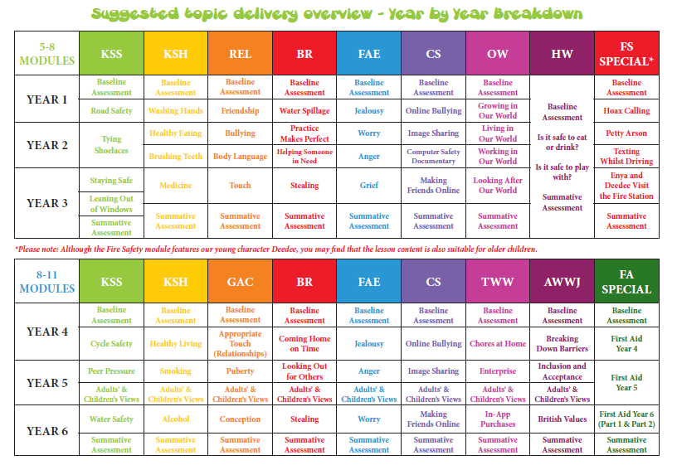
Walkern Primary School – PSHE Sequence of learning

